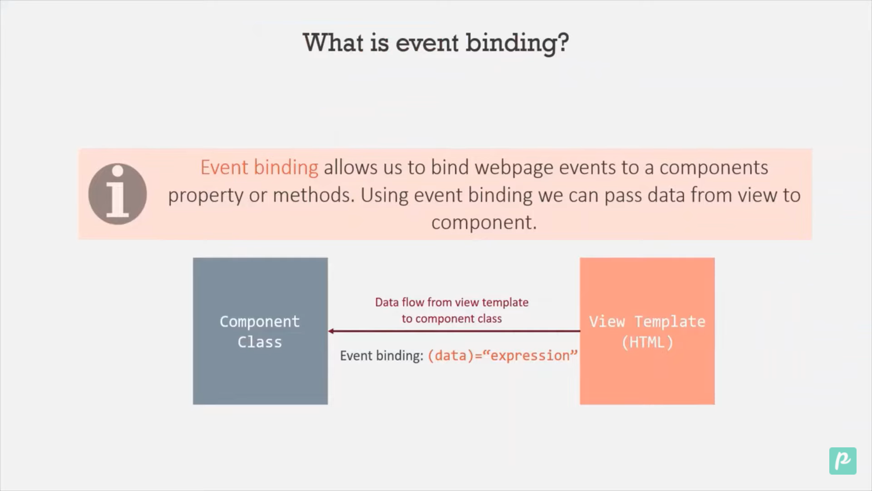

We will create one component search and then use event binding

<div class="search-div">

  <span><b>Search</b></span>

  <input type="text" (input)="changeInputValue($event)" />

  <span>You search for "{{ searchValue }}"</span>

</div>

Now in class component

import { Component } from '@angular/core';

@Component({

  selector: 'app-search',

  templateUrl: './search.component.html',

  styleUrls: ['./search.component.css'],

})

export class SearchComponent {

  searchValue: string = '';

  changeInputValue(eventData: any) {

    this.searchValue = (<HTMLInputElement>eventData.target).value;

  }

}

How to perform two way data binding.

We have to use ngModel and import it import in appmodule and declare inimport sections.

Step 1: In appmodule we have to import

import { FormsModule } from '@angular/forms';

Step 2: Declare

imports: [BrowserModule, FormsModule],

Step 3: Now we can use ngmodule in htmlview

<!-- Both way binding example -->

  <input type="text" [(ngModel)]="searchValue1" />

  <span>You search for "{{ searchValue1 }}"</span>

</div>

Step 4: In class module we have to use

@Component({

  selector: 'app-search',

  templateUrl: './search.component.html',

  styleUrls: ['./search.component.css'],

})

export class SearchComponent {

  searchValue: string = '';

  searchValue1: string = 'Try';

  // This for event binding

  changeInputValue(eData: any) {

    this.searchValue = (<HTMLInputElement>eData.target).value;

  }

}